

**PRACTICAL FILE: - COMPUTER NETWORKS**

**RAJDHANI COLLEGE**

**UNIVERSITY OF DELHI**

**NAME: -** Rajkumar Choudhury

**ROLL NO. –** 8751

**UNIVERSITY ROLL NO. –** 19055582140

**COURSE: -** B.Sc. (Prog.) Computer Science

**SEMESTER –** 6th , **YEAR –** 3rd

**SUBMITTED TO: -** Meenakshi Mam

**HTML Practical**

1. Write a HTML program to design a form which should allow to enter your personal data.

(Hint: make use of text field, password field, e-mail, lists, radio buttons, checkboxes, submit button).

<!DOCTYPE html>

<html lang="en">

<head>

    <title>Practical 1</title>

</head>

<body>

    <h2>Enter Your Details</h2>

    <form>

        <p>Name: <input type="text" name="name" id=""></p>

        <p>Age: <input type="number" name="age" id=""></p>

        <fieldset>

            <legend>Gender </legend>

            <p>Male <input type="radio" name="gender" id="male" ></p>

            <p>Female<input type="radio" name="gender" id="female" ></p>

            <p>Others <input type="radio" name="gender" id="others"></p>

        </fieldset>

        <p>

            Address: <textarea name="address" id="" cols="50" rows="5"></textarea>

        </p>

        <p>Course Type:

            <select name="course type" id="course" >

                <option value="">--Select--</option>

                <option value="bsc">B.Sc.</option>

                <option value="bcom">B.Com</option>

                <option value="ba">B.A.</option>

            </select>

        </p>

        <p>SEC Opted:

            <input type="checkbox" name="sec" id="webdev">Web Development

            <input type="checkbox" name="sec" id="programming">Advanced Programming in Java

        </p>

        <h2>Log Into Your Account</h2>

        <p>Email:<input type="email" name="email" id="" ></p>

        <p>Password: <input type="password" name="password" id=""></p>

        <input type="submit" value="Submit">

    </form>

</body>

</html>

**OUTPUT**

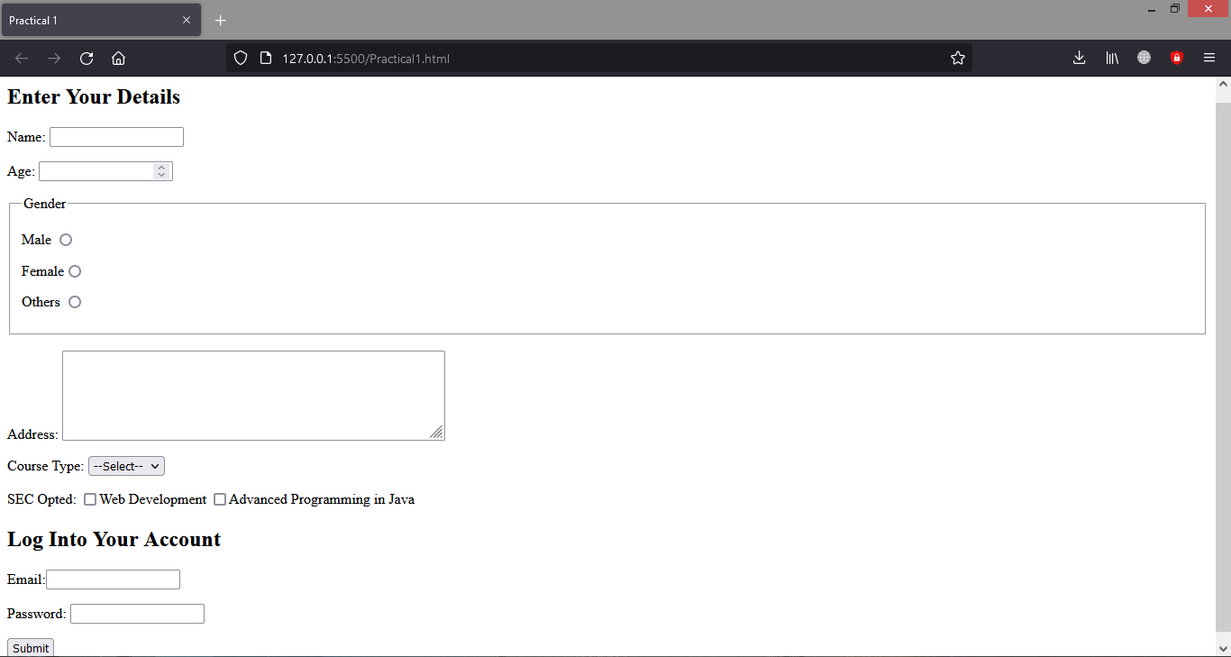

1. Write html code to generate following output.

• Coffee

• Tea

o Black Tea

o Green Tea

• Milk

<!DOCTYPE html>

<html lang="en">

<head>

    <title>Practical 2</title>

</head>

<body>

    <ul>

        <li>Coffee</li>

        <li>Tea</li>

        <ul type ="circle">

            <li>Black Tea</li>

            <li>Green Tea</li>

        </ul>

        <li>Milk</li>

    </ul>

</body>

</html>

**OUTPUT**

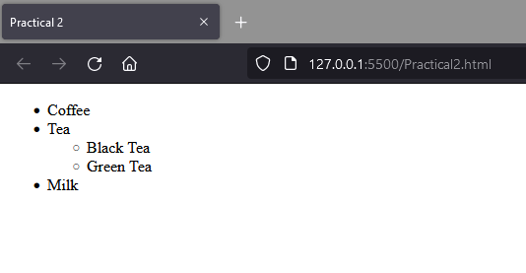

1. Design an html form to take the information of a customer visiting a departmental store such as name, contact phone no, preferred days of purchasing, favourite item (to be selected from a list of items), suggestions etc. One should provide button to Submit as well as Reset the form contents.

<!DOCTYPE html>

<html lang="en">

<head>

    <title>Practical 3</title>

</head>

<body>

    <h1>Departmental Store Feedback Form</h1>

    <form>

        <p>Customer Name: <input type="text" name="name" id=""></p>

        <p>Contact Number: <input type="number" name="number" id=""></p>

        <p>Email ID: <input type="email" name="email" id=""></p>

        <p>Address : <br><textarea name="address" id="" cols="20" rows="5"></textarea></p>

        <fieldset>

            <legend>Preferred Days For Purchasing:</legend>

            <p><input type="checkbox" name="" id="sun" >Sunday</p>

            <p><input type="checkbox" name="" id="mon" >Monday </p>

            <p><input type="checkbox" name="" id="tue">Tuesday</p>

            <p><input type="checkbox" name="" id="wed">Wednesday </p>

            <p><input type="checkbox" name="" id="thu" >Thursday</p>

            <p><input type="checkbox" name="" id="fri" >Friday </p>

            <p><input type="checkbox" name="" id="sat">Saturday</p>

        </fieldset>

        <p>Favourite Item:

            <select name="fav item" id="fav" >

                <option value="">--Select--</option>

                <option value="clothes">Clothes</option>

                <option value="grocery">Grocery </option>

                <option value="sports">Sports Items</option>

                <option value="cosmetics">Cosmetics</option>

                <option value="electronics">Electronics And Appliances</option>

            </select>

        </p>

        <p>Suggestions: <br><textarea name="suggestions" id="" cols="20" rows="5"></textarea></p>

        <input type="submit" value="Submit">

        <input type="reset" value="Reset">

    </form>

</body>

</html>

**OUTPUT**

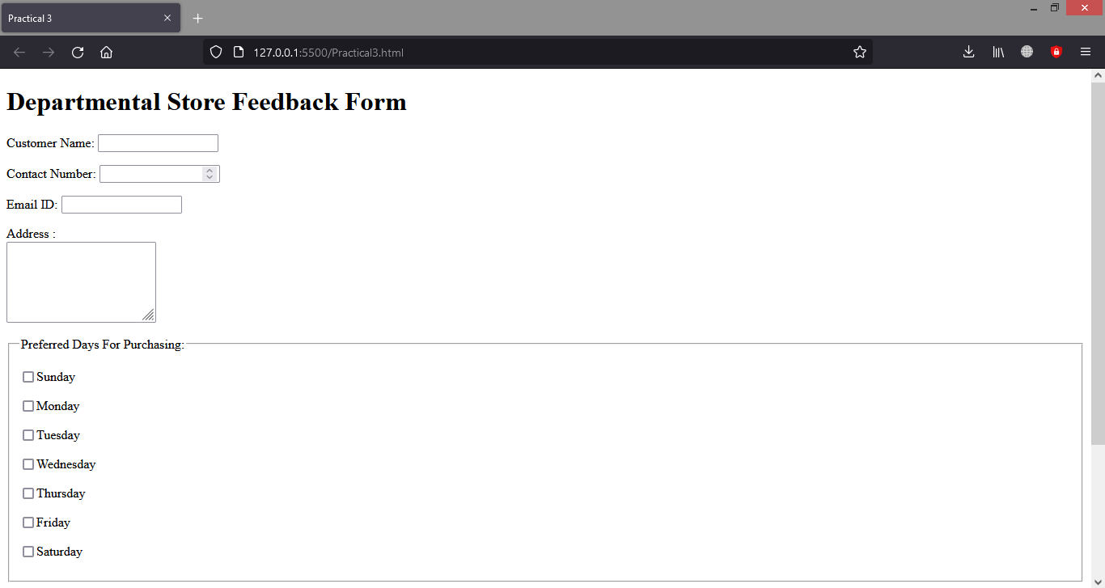

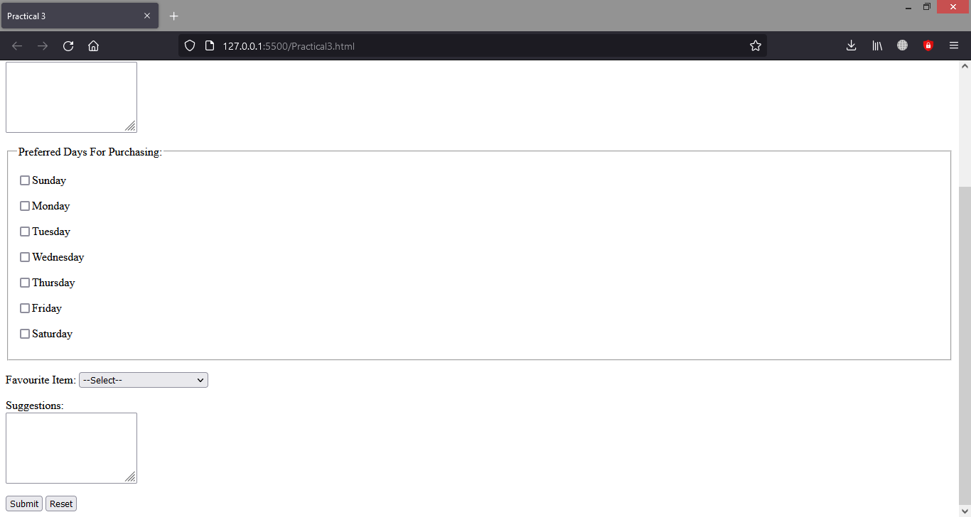

1. Design an html form to take the information of an article to be uploaded such as file path, author name, type (technical, literary, general), subject topic (to be selected from a list) etc. One should provide button to Submit as well as Reset the form contents.

<!DOCTYPE html>

<html lang="en">

<head>

    <title>Practical 4</title>

</head>

<body>

    <h1>Article Information</h1>

    <form action="">

        <p>Article Name: <input type="text" name="aname" id=""></p>

        <p>Author Name: <input type="text" name="name" id=""></p>

        <p>Upload Your Article Here: <input type="file" name="file" id=""></p>

        <fieldset>

            <legend>Type Of Article: </legend>

            <p>Technical <input type="radio" name="atype" id="technical" ></p>

            <p>Library <input type="radio" name="atype" id="library" ></p>

            <p>General <input type="radio" name="atype" id="general"></p>

        </fieldset>

        <p>Subject Type:

            <select name="sub type" id="sub" >

                <option value="">--Select--</option>

                <option value="economics">Economics</option>

                <option value="politics">Politics</option>

                <option value="sports">Sports</option>

                <option value="entertainment">Entertainment</option>

                <option value="international">International</option>

            </select>

        </p>

        <input type="submit" value="Submit">

        <input type="reset" value="Reset">

    </form>

</body>

</html>

**OUTPUT**

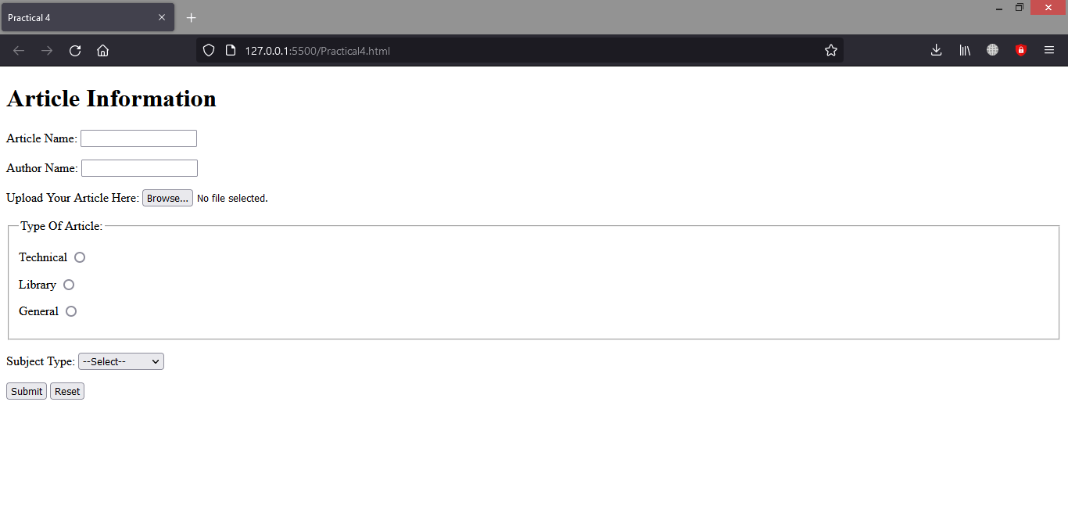

1. Design an HTML document using Table related tags align the images

<!DOCTYPE html>

<html lang="en">

<head>

    <title>Practical 5</title>

</head>

<body>

    <table border= 1 height="200" width ="500" align="center" style="margin-top: 100px;">

        <tr>

            <td><img src="i1.png" alt="" height="100"></td>

            <td align = "center"><img src="i2.jpg" alt="" height="100"></td>

            <td><img src="i3.png" alt="" height="100"></td>

            <td align="center"><img src="i4.jpg" alt="" height="100"></td>

        </tr>

        <tr>

            <td><img src="i5.png" alt="" height="100"></td>

            <td colspan="2" align="center">Multi-Millionare Companies</td>

            <td><img src="i6.jpg" alt="" height="100"></td>

        </tr>

        <tr>

            <td><img src="i7.jpg" alt="" height="100"></td>

            <td><img src="i8.png" alt="" height="100"></td>

            <td><img src="i9.jpg" alt="" height="100"></td>

            <td><img src="i5.png" alt="" height="100"></td>

        </tr>

    </table>

</body>

</html>

**OUTPUT** 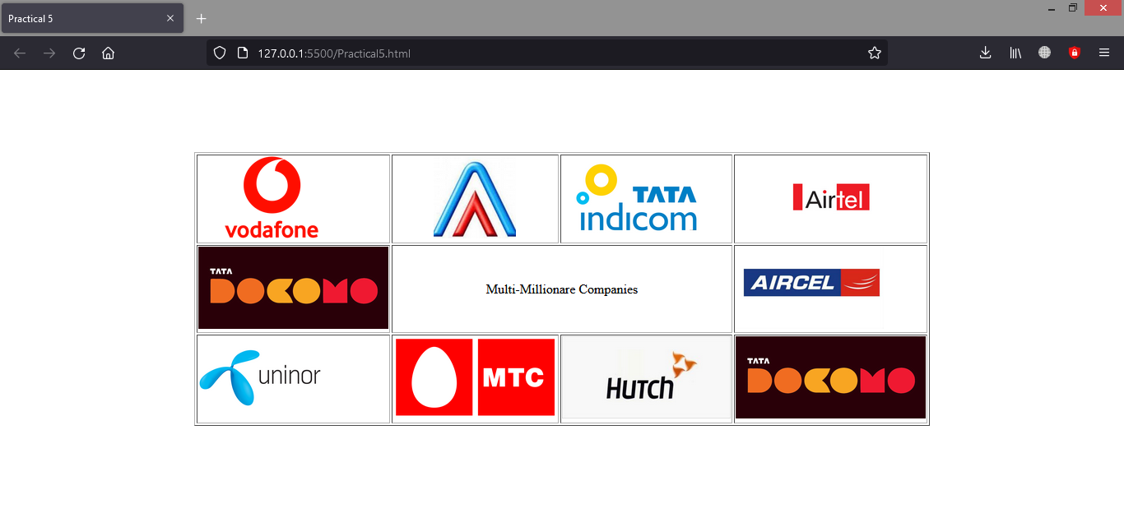

1. Write a HTML code to generate following output.

<!DOCTYPE html>

<html lang="en">

<head>

    <title>Practical 6</title>

    <style>

        .d

        {

            border: 2px solid black;

            padding: 10px;

        }

        .s

        {

            border: 2px solid black;

            font-size: 20px;

        }

    </style>

</head>

<body>

    <div class="d">

    <form>

    <p>Enter Name of your friend: <input type="text" name="name" id=""></p>

    <p>Choose the file you want to post to your friend  <br><input type="file" name="file" id=""></p>

    <p>What does the file contain? <br>

        <input type="checkbox" name="con" id="image">Image

        <input type="checkbox" name="con" id="code">Source Code

        <input type="checkbox" name="con" id="binary">Binary Code

    </p>

    You have Completed the Form.

    <input class ="s" font type="submit" value="Submit Query">

</form>

</div>

</body>

</html>

**OUTPUT**

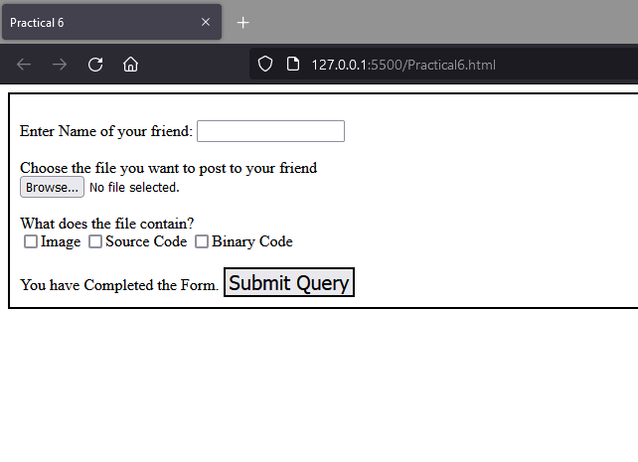

1. Develop static pages (using only HTML) of an online Book store.The website should consist of following pages.

* Home page
* Registration and user Login
* User profile page
* Books catalog
* Shopping cart
* Payment by credit card Order Conformation

Main.html

<!DOCTYPE html>

<html lang="en">

<head>

                <title>Online Book Store</title>

</head>

<frameset cols="25%,*">

                <frame name="left" src="frame.html" >

                <frame name="right" src="First.html">

<body>

</body>

</html>

Frame.html

<!DOCTYPE html>

<html lang="en">

<head>

                <title>Left Frame</title>

</head>

<body style="background-color: lightskyblue; margin-top: 100px;">

    <ul>

        <li>

       <a href="login.html" target="right">

            LOGIN</a>

     </li>

     <br><br>

        <li>

       <a href="register.html" target="right">

            REGISTRATION</a>

     </li> <br><br>

        <li>

       <a href="profile.html" target="right">

            USER PROFILE</a>

     </li> <br><br>

        <li>

       <a href="catalog.html" target="right">

            BOOKS CATALOG</a>

     </li>  <br><br>

        <li>

       <a href="shopcart.html" target="right">

            SHOPPING CART</a>

     </li> <br><br>

        <li>

       <a href="pay.html" target="right">

            PAYMENT</a>

     </li> <br><br>

   </ul>

</body>

</html>

First.html

<html>

<head>

    <style>

        h1{

            padding-top: 75px;

        }

    </style>

<title>

Online Book Store</title>

</head>

<body> <center>

<strong><i><h1>Welcome to our Online Book Store</h1></i></strong>

<br><br><h2>Click on the links present on the left side to proceed to your required page</h2>

</center>

</body>

</html>

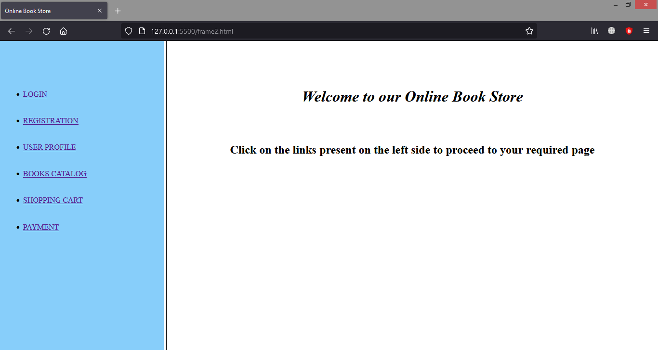

Login.html

<html>

  <body>

    <br>  <br>

       <form>

      <h1 align="center" style="background-color:lightskyblue">Log in</h2>

        <hr>

           <div align=”center”>

          <pre>

   LOGIN ID:<input type=”text” name=”id”><br>

   PASSWORD:<input type=”password” name=”pword”>

  </pre>

        </div>

           <br><br>

           <input type="submit">

           <input type="reset">

    </form>

  </body>

</html>

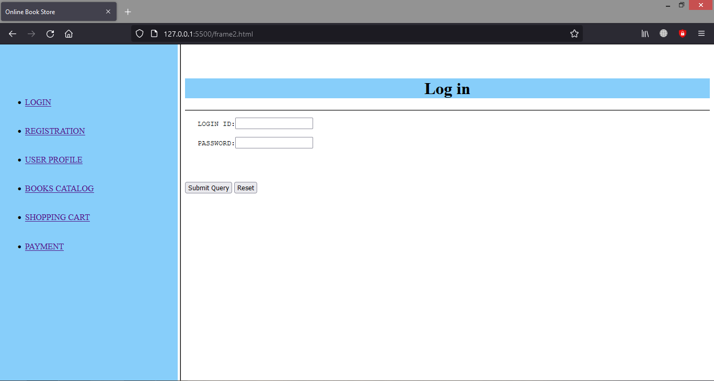

Register.html

<html>

<body><br><br>

          <form>

    <div style="background-color:lightskyblue">

      <h1 align="center">Register</h1>

    </div>

         <pre>

 NAME:<input type="text" name="name">

<br>

 ADDRESS:<input type="type" name="address">

 <br>

 CONTACT NUMBER:<input type="text" name="phno">

     <br>

     <hr>

 LOGIN ID:<input type="text" name="id">

<br>

 PASSWORD:<input type="password" name="pwd">

</pre>

    <br><br>

    <input type="submit">

    <input type="reset">

  </form>

</body>

</html>

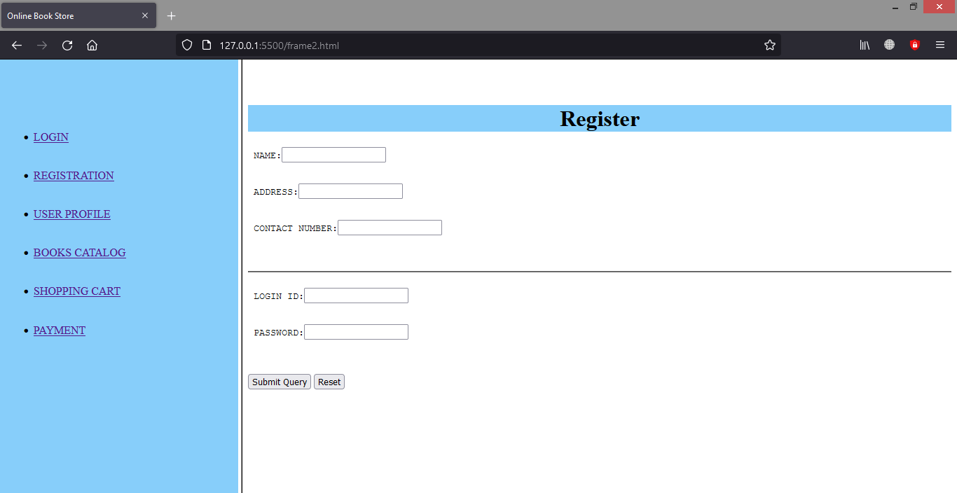

Profile.html

<!DOCTYPE html>

<html>

  <head>

    <title>userprofile</title>

  </head>

  <body>

    <center>

      <strong>

  <h1 style="background-color:lightskyblue">Welcome to Online Book Store </h1>

  </strong>

    </center>

    <b>Edit your profile here...</b>

    <form method="post" action="catalog.html">

      <right>

        <table align="left">

          <tr>

            <td>

              <h4>Edit UserName

            </td>

            <td><input type="text"></td>

          </tr>

          <tr>

            <td>

              <h4>Edit Password

            </td>

            <td><input type="password"></td>

          </tr>

          <tr>

            <td>Gender:</td>

            <option>

              <td>

                <h4>Male

                  <input type="radio" name="sex" id="male">

              </td>

              <td>

                <h4>Female

                  <input type="radio" name="sex" id="female">

              </td>

            </option>

          </tr>

          <tr>

            <td>Edit Address</td>

            <td><textarea name="address" rows=5 cols=19>

</textarea>

            </td>

          <tr>

            <td>

              <input type="submit" value="submit">

            </td>

          </tr>

    </form>

  </body>

</html>

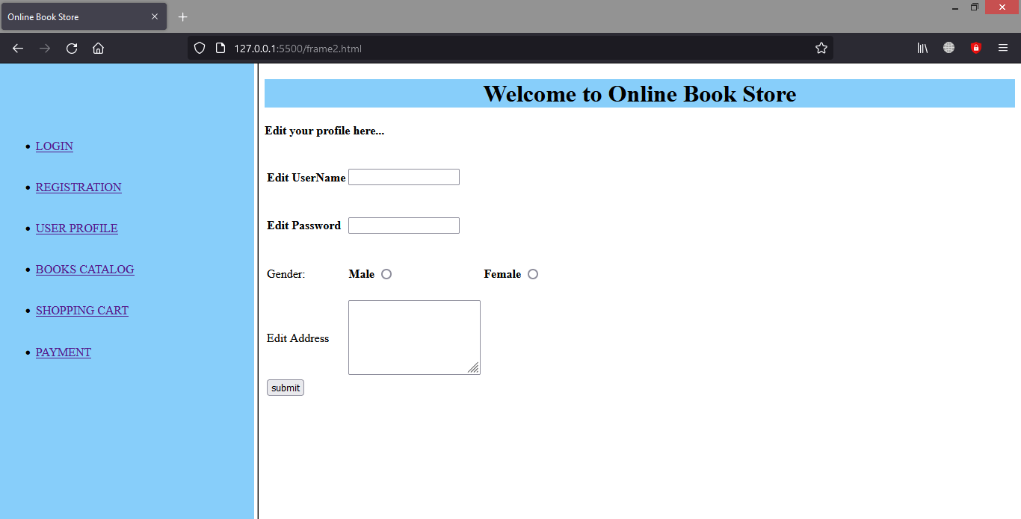

Catalog.html

<html>

<head>

  <title>

    books catalog</title>

</head>

<body>

  <center>

    <h1 style="background-color:lightskyblue">Books Catalog</h1>

  </center>

  <form action="shopping.html">

    <left>

      <table>

        <tr>

          <td><b>

              <h3>Frontend Books</td>

          <td></td>

        </tr>

        <tr>

          <td></td>

          <td>

            <h4>HTML 5

          </td>

        </tr>

        <tr>

          <td></td>

          <td>

            <h4>CSS 3

          </td>

        </tr>

        <tr>

          <td></td>

          <td>

            <h4>JAVASCRIPT

          </td>

        </tr>

        <tr>

          <td><b>

              <h3>Backend Books</td>

          <td></td>

        </tr>

        <tr>

          <td></td>

          <td>

            <h4>PHP

          </td>

        </tr>

        <tr>

          <td></td>

          <td>

            <h4>Ms SQL Server

          </td>

        </tr>

        <tr>

          <td></td>

          <td>

            <h4>MySql

          </td>

        </tr>

      </table>

      </h4>

  </form>

</body>

</html>

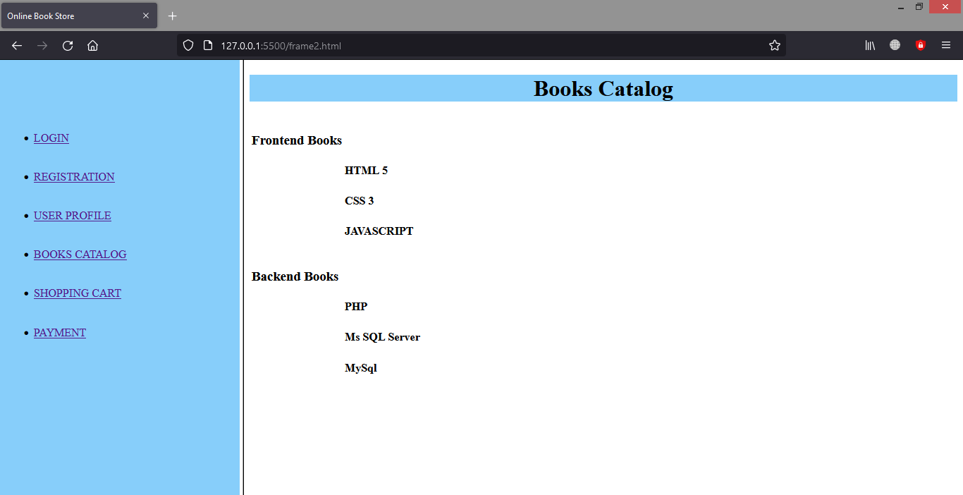

Shopcart.html

<!DOCTYPE html>

<html lang="en">

  <head>

    <title>Shopping Cart</title>

  </head>

  <body>

    <h1 style="background-color:lightskyblue" align="center">Shopping Cart</h1>

    <form>

      <fieldset>

        <label>Item Code: <input type="text" name="name"></label>

        <br><br>

        <label>Quantity: <input type="text" name="data"></label>

        <br><br>

        <input type="button" value="Save">

        <input type="button" value="Add to wishlist">

      </fieldset>

      <br>

      <hr style="height:5px ; background: black">

      <div id="items_table">

        <h2 style="text-align:center">Shopping List</h2>

        <table></table>

        <label><input type="button" value="Clear">

          * Delete all items</label>

      </div>

    </form>

  </body>

</html>

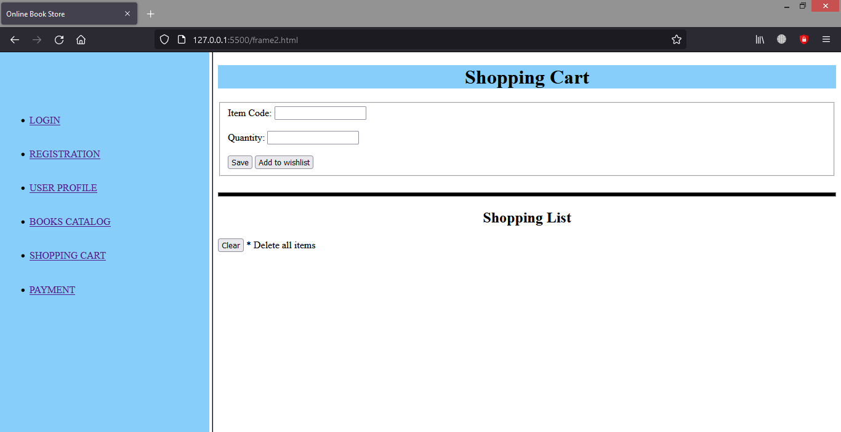

Pay.html

<!DOCTYPE html>

<html lang="en">

<head>

    <title>Payment Form</title>

    <link rel="stylesheet" href="style.css">

</head>

<body>

    <div class="box">

    <form method="POST">

        <h1>Payment Form</h1><hr>

        <h2>Contact Information</h2><br>

        <p>Name: *<input type="text" name="name" id="h" required></p>

        <fieldset>

            <legend>Gender *</legend>

            <p>Male <input type="radio" name="gender" id="" required></p>

            <p>Female<input type="radio" name="gender" id="" required></p>

        </fieldset>

        <p>

            Address: <br><textarea name="address" id="1" cols="50" rows="5"></textarea>

        </p>

        <p>Email: *<input type="email" name="email" id="email" required></p>

        <p>Pincode: *<input type="number" name="pincode" id="pincode" required placeholder="123456"></p>

        <hr>

        <h2>Card Details</h2 id="hello"><br>

        <p>Card Type: *

            <select name="card type" id="card type" required>

                <option value="">--Select--</option>

                <option value="rupay">Rupay</option>

                <option value="mastercard">MasterCard</option>

                <option value="visa">Visa</option>

            </select>

        </p>

        <p>Card Number: *<input type="number" name="card number" id="card number" required></p>

        <p>Expiration Date: *<input type="date" name="exp date" id="exp date" required></p>

        <p>CVV: *<input type="password" name="cvv" id="cvv" required></p>

        <p>Would you like to save your card information on this site?

            <input type="checkbox" name="yes" id="">Yes, I would love to

            <input type="checkbox" name="no" id="">No, I wouldn't

        </p>

        <input type="reset" value="Reset">

        <input type="submit" value="Pay">

    </form></div>

</body>

</html>

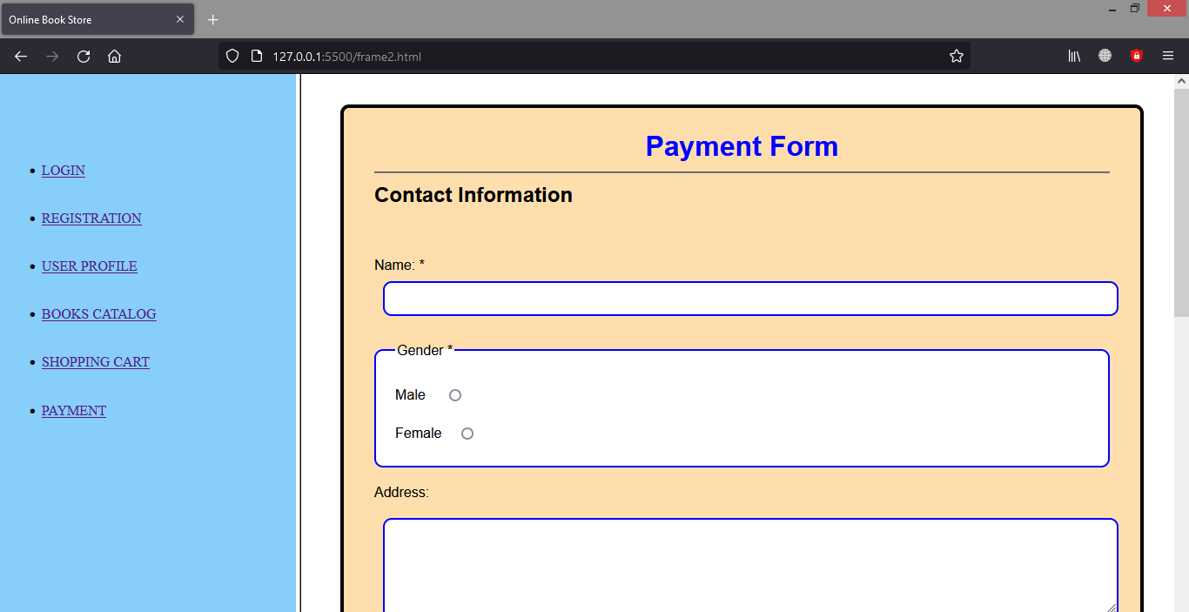

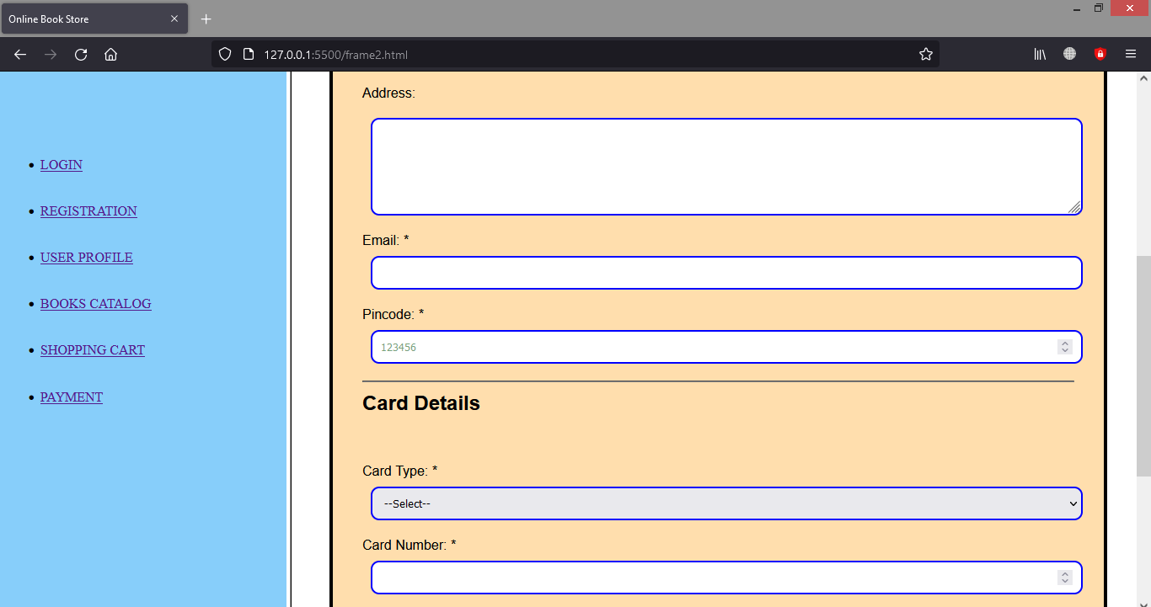

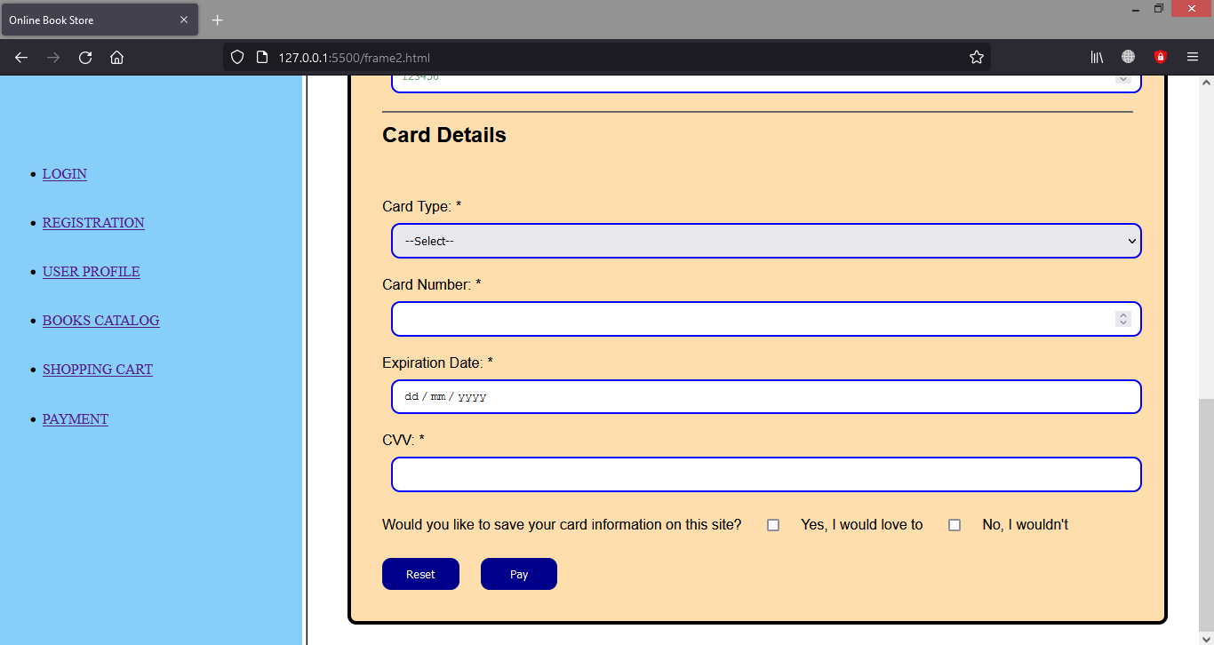

**NETWORK ALGORITHMS PRACTICAL**

1. Simulate Cyclic Redundancy Check (CRC) error detection algorithm for noisy channel.

#include <iostream>

#include<string>

using namespace std;

int find(string newdata ,string div,int len);

int divide(string newdata,string div,int len);

int main()

{

string data,div="";

cout << "For Sender =>" << endl;

cout << "Enter Data: ";

cin >> data;

cout << "Enter Divisor: ";

cin >> div;

int len=div.length();

string newdata=data;

for (int i=1;i<len;i++)

{

newdata+="0";

}

int final=find(newdata,div,len);long long newdata1=0;

newdata1=stoll(newdata);

long long finalans=newdata1+(long long)final;

string codeword=to_string(finalans);

cout << "\nThe Codeword sent to receiver is: " << codeword << endl;

int check=find(codeword,div,len);

cout << "\nThe Remainder on the Receiver side is: "<< check << endl;

if(check==0)

cout << "This Shows us that Data is recieved Correctly";

else

cout << "This Shows us that Data is recieved Incorrectly";

}

int divide(string dividend,string divisor,int len)

{

string s="";

for(int i=0;i<len;i++)

{

if(dividend[i]==divisor[i])

s+="0";

else

s+="1";

}

int ans=stoi(s);

return ans;

}

int find(string dividend,string divisor,int len)

{

string newdiv="";int rem=0;

int i=0;

for (i=0;i<len;i++)

{

newdiv+=dividend[i];

}

while(i<=dividend.length())

{

int ans=divide(newdiv,divisor,len);

string newans=to_string(ans);

newdiv="";

newdiv+=newans;

int newl=newans.length();

if(i!=dividend.length())

{

for(int j=newl;j<len;j++)

{

newdiv+=dividend[i];

i++;

}

}

rem=stoi(newdiv);

if(newdiv.length()<len)

break;

}

return rem;

}

**OUTPUT**

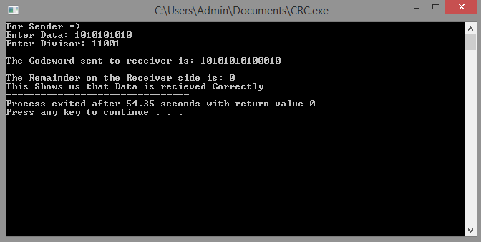

2. Simulate and implement stop and wait protocol for noisy channel.

#include <iostream>

#include<string>

#include <windows.h>

using namespace std;

string rdata="";

int check=-1;

int send(char ch,int x);

int receive (char ch,int x);

int random();

int main()

{

string data;

cout << "Enter Data to be sent : ";

cin >> data ;cout << endl;

for(int i=0;i<data.length();i++)

{

send(data[i],i);

}

cout << "Received Data : " << rdata;

}

int send(char ch,int x)

{

cout << "Data Sent : " << x << endl;

int ans = receive(ch,x);

if(ans==1)

{

int s=random();

if(s<5)

{

if(random()<5)

cout << "Acknowledgement Received " << endl <<endl;

else

{

Sleep(3000);

cout << "TIMEOUT - Delayed Acknowledgement " << endl << endl;

send(ch,x);

}

}

else

{

Sleep(3000);

cout << "TIMEOUT - Loss Of Acknowledgement " << endl << endl;

send(ch,x);

}

}

else

{

Sleep(3000);

cout << "TIMEOUT - Loss Of Data " << endl << endl;

send(ch,x);

}

}

int receive(char ch,int j)

{

int r=random();

if(r<5)

{

if(check==j)

{

cout << "Data Received " << endl;

cout << "Duplicate Data Found And Hence Discarded "<< endl;

cout << "Acknowledgement Sent : " << j << endl;

}

else

{

check=j;

cout << "Data Received " << endl;

cout << "Acknowledgement Sent : " << j << endl;

rdata+=ch;

}

return 1;

}

else

return 0;

}

int random()

{

return rand()%10;

}

**OUTPUT**

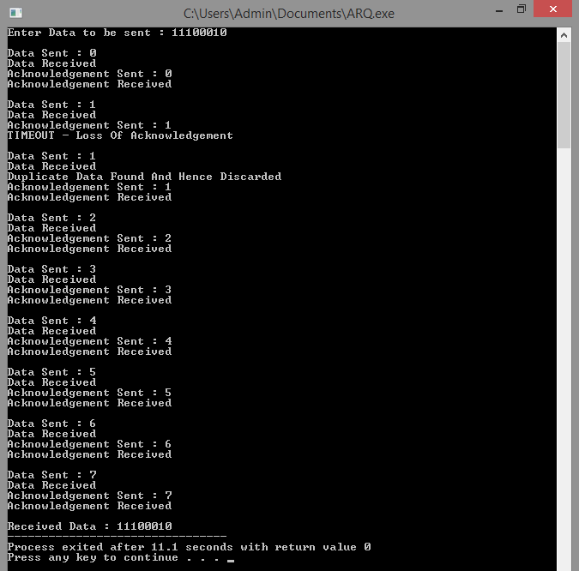

3. Simulate and implement go back n sliding window protocol.

#include <iostream>

#include<string>

#include <windows.h>

using namespace std;

string rdata="";int n=0;

int check=-1;

int send(string s);

int receive (char ch,int x);

int random();

int resend(int x,int l);

int window (int x,int l);

int main()

{

string data;

cout << "Enter Data to be sent : ";

cin >> data ;

cout << "Enter Window Size : ";

cin >> n ; cout << endl;

resend(0,data.length());

send(data);

cout << "\nReceived Data : " << rdata;

}

int send(string s)

{

for (int i=0;i<s.length();i++)

{

int l=s.length();

int ans = receive(s[i],i);

if(ans==1)

{

window(i+n,l);

}

else

{

Sleep(3000);

cout << "TIMEOUT - Loss Of Acknowledgement \n" << endl;

resend(i,l);

i--;

}

}

}

int receive(char ch,int j)

{

if(random()<9)

{

if(check==j)

{

cout << "Duplicate Data Found And Hence Discarded "<< endl;

cout << "Acknowledgement Sent : " << j << endl;

}

else

{

check=j;

cout << "Acknowledgement Sent : " << j << endl;

rdata+=ch;

}

return 1;

}

else

return 0;

}

int random()

{

return rand()%10;

}

int window(int x,int l)

{

if(x<l)

cout << "Data Sent : " << x << endl << endl;

}

int resend(int x,int l)

{

if(random()<9)

{

for(int i=0;i<n && i+x<l;i++)

{

cout << "Data Sent : " << i+x << endl;

}

cout << endl;

}

else

{

Sleep(3000);

cout << "TIMEOUT - Loss Of Data\n" << endl;

resend(x,l);

}

}

**OUTPUT**

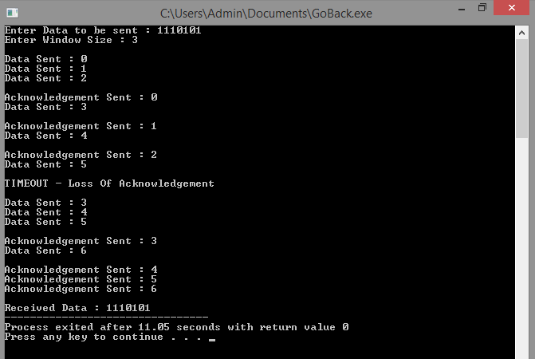

4. Simulate and implement selective repeat sliding window protocol.

#include <iostream>

#include<string>

#include <windows.h>

using namespace std;

string rdata="";int n=0;

int check=-1;

int send(string s);

int receive (char ch,int x);

int random();

int resend(int x,int l);

int window (int x,int l);

int main()

{

string data;

cout << "Enter Data to be sent : ";

cin >> data ;

cout << "Enter Window Size : ";

cin >> n ; cout << endl;

resend(0,data.length());

send(data);

cout << "\nReceived Data : " << rdata;

}

int send(string s)

{

for (int i=0;i<s.length();i++)

{

int l=s.length();

int ans = receive(s[i],i);

if(ans==1)

{

window(i+n,l);

}

else

{

Sleep(3000);

cout << "TIMEOUT - Loss Of Acknowledgement \n" << endl;

window(i,l);

i--;

}

}

}

int receive(char ch,int j)

{

if(random()<9)

{

if(check==j)

{

cout << "Duplicate Data Found And Hence Discarded "<< endl;

cout << "Acknowledgement Sent : " << j << endl;

}

else

{

check=j;

cout << "Acknowledgement Sent : " << j << endl;

rdata+=ch;

}

return 1;

}

else

return 0;

}

int random()

{

return rand()%10;

}

int window(int x,int l)

{

if(x<l)

cout << "Data Sent : " << x << endl << endl;

}

int resend(int x,int l)

{

if(random()<9)

{

for(int i=0;i<n && i+x<l;i++)

{

cout << "Data Sent : " << i+x << endl;

}

cout << endl;

}

else

{

Sleep(3000);

cout << "TIMEOUT - Loss Of Data\n" << endl;

resend(x,l);

}

}

**OUTPUT**

